**STUDENT NAME:**

**DATE:**

**USING LINEAR REGRESSION TO DETERMINE SALES OUPUT**

1. We use the trsanactions.csv file to predict the revenue income (which we may call future sales for now) based on the amount of the transactions that the company received. When we load the dataset into the Studio we get the below;

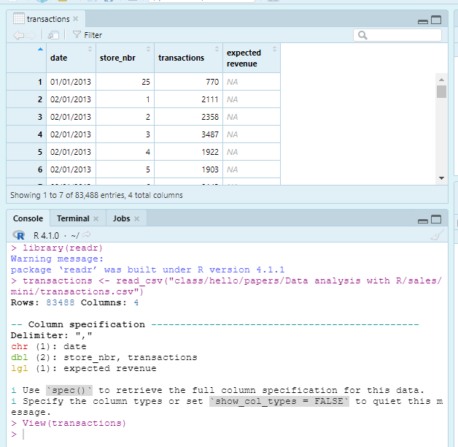

1. Then we create a data frame which will be used to store a transaction (800), this is the transaction we want to predict and do not know its value yet;

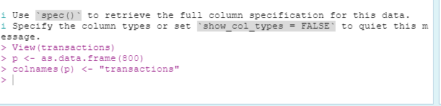

1. Since we have the store number in the store dataset and the store number in the transaction dataset. We can now combine two numerical values under the transaction sheet with the cluster and the traction amount to try and predict the outcome of the revenue based on the provided columns

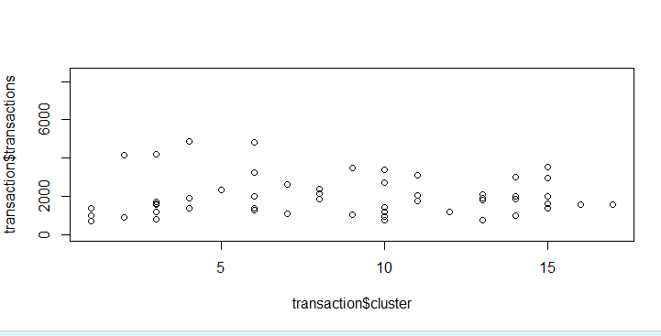

A plot of the two variables tries to give us somewhat a correlations showing a cluster

**If we try to get the summary of the linear model**

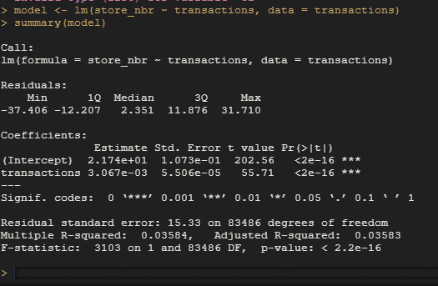

Based on the model above, we can predict the future transaction of cluster

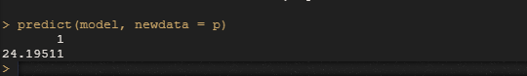

**Random forest**

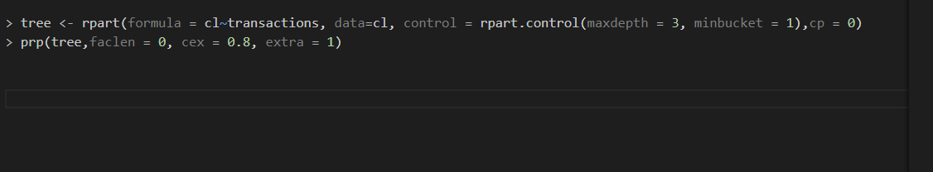

**TIME SERIES MODEL WITH ARIMA**

> View(sales)

> plot.ts(sales)

# GET THE TIMES SERIES

> library(ggplot2) ggplot(sales, aes(id, sales)) + geom_line()

> library(ggplot2)

> ggplot(sales, aes(id, sales)) + geom_line()

#PREDICT THE NEXT CLUSTER OF SHOPS OVERTIME

plot(diff(log(sales$sales)),type='l', main='log returns plot')

#STEP 4 STATIONARISE THE TIME SERIES

>adf.test(diff(log(as.numeric(sales$sales))), alternative="stationary", k=0)

#STEP 5 CALCULATE THE ACF PACF ON OUR DATASET BASED ON SHOP CLUSTERS

>acf(diff(log(sales$sales)))

>pacf(diff(log(sales$sales)))

#STEP 6

#CALL OUR FORECAST LIBRARY INSIDE ARIMA MODEL

> library(forecast)

> (fit <- arima(diff(log(sale$sales)), c(3, 0, 1)))

#FITTING OUR ARIMA

> fitARIMA <- auto.arima(diff(log(sales$sales)), trace=TRUE)

#CHECKNG TO SEE HOW OUR ARIMA MODEL FITTED WITH THE TRAINING DATASET

> plot(as.ts(diff(log(sales$sales))) )

> lines(fitted(fitARIMA), col="red")

#STEP 7

#MAKING A PREDICTION BASED ON OUR ARIMA MODEL

 >futurVal <- forecast(fitARIMA,h=5, level=c(99))

> plot(forecast(futurVal))

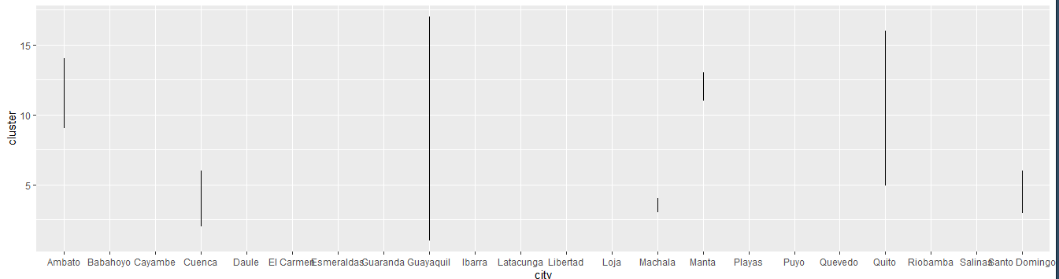

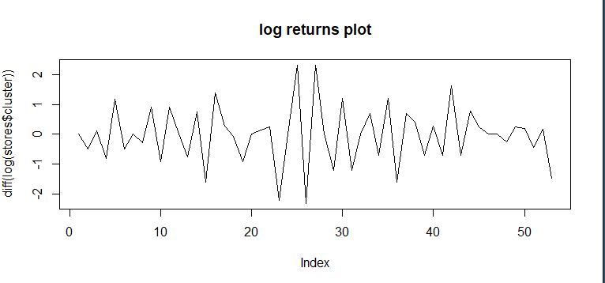

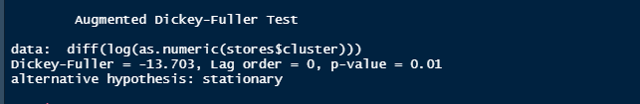

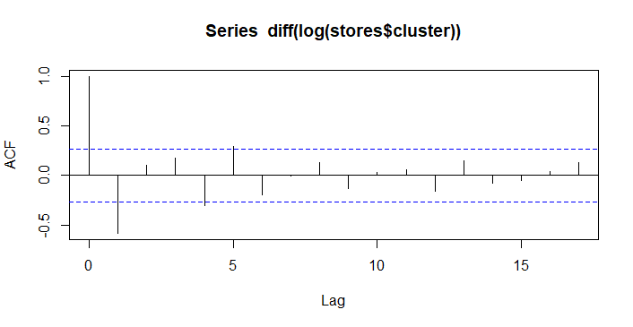

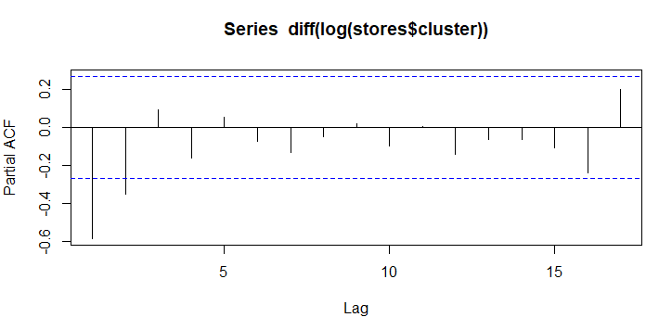

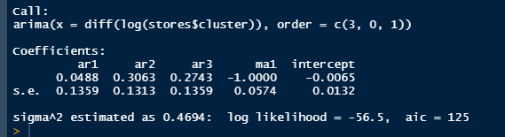

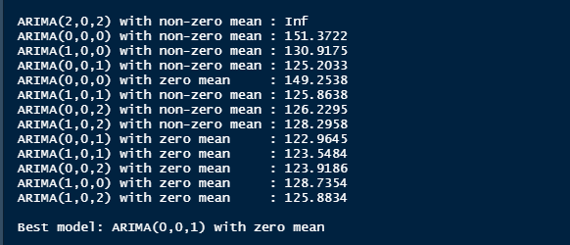

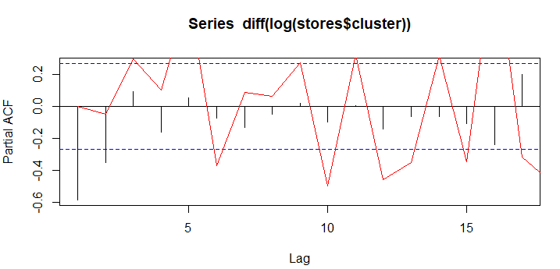

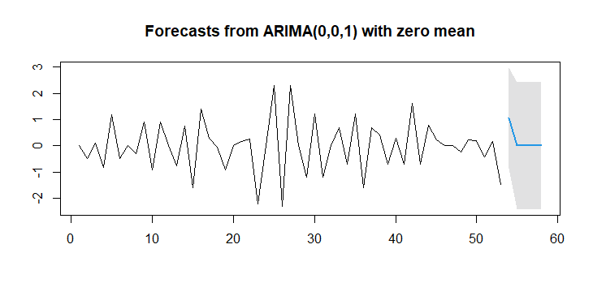

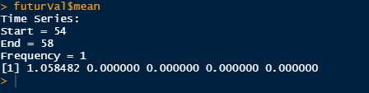

**RNN MODEL**

## STEP 3

 ##WE USE MOVING BLOCK SUB SAMPLING TO ENABLE US CUT OUR VECTOR INTO SMALL BITS FOR EASIER SAMPLING

> start_indexes <- seq(1, length(sales_type)- (max_len + 1), by = 3)

> cluster_matrix <- matrix(nrow = length(start_indexes), ncol = max_len + 1)

> for (i in 1:length(start_indexes)){cluster_matrix [i,] + max_len)]}

> for (i in 1:length(start_indexes))

{cluster_matrix [i,] <-store_type[start_indexes[i]:(start_indexes[i] + max_len)]}

#REMOVE WARNING MESSAGES

> dev.off()

null device

## STEP 4

#WE REMOVE N/A values and converting our matrix to NUMERIC

> for (i in 1:length(start_indexes))

{cluster_matrix [i,] <-store_type[start_indexes[i]:(start_indexes[i] + max_len)]}

> cluster_matrix <- cluster_matriX * 1

> cluster_matrix <- suppressWarnings(as.numeric(cluster_matrix) * 1)

> if(anyNA(cluster_matrix)){

+     cluster_matrix <- na.omit(cluster_matrix)

+ }

## STEP 5

#SEPARATE OUR DATA INTO PREVIOUS DAYS AND THEN DEFINE DAYS WE WANT TO PREDICT FOR THE STORE TYPE IN Y VARIABLE

X <- cluster_matrix[,-ncol(cluster_matrix)]

y <- cluster_matrix[,ncol(cluster_matrix)]

## STEP 6

# THIS INDEXING WILL SEPARATE OUR DATA INTO TRAINING AND TESTING UNITS

training_index <- createDataPartition(y, p = .9,

                                  list = FALSE,

                                  times = 1)

## STEP 7

# THEN TRAIN THE DATA

X_train <- array(X[training_index,], dim = c(length(training_index), max_len, 1))

y_train <- y[training_index]

## STEP 7

# THEN TEST THE DATA

X_test <- array(X[-training_index,], dim = c(length(y) - length(training_index), max_len, 1))

y_test <- y[-training_index]

## STEP 8

# DEFINE A NEW MODEL FOR THE STORES DATASET

stores_cluster_model <- keras_model_sequential()

# DEFINE NEW DIMENSIONS FOR INPUT DATA

dim(X_train)

## STEP 9

# THEN DEFINE INPUT LAYER OF THE MODEL

stores_cluster_model %>%

    layer_dense(input_shape = dim(X_train)[2:3], units = max_len)

stores_cluster_model %>%

    layer_simple_rnn(units = 6)

stores_cluster_model %>%

    layer_dense(units = 1, activation = 'sigmoid')

# TO GET A SUMMARY OF THE MODEL STRUCTURE USE summary command

summary(stores_cluster_model)

## STEP 10

# TRAINING THE MODEL

stores_cluster_training_model <- stores_cluster_model %>% fit(

    x = X_train,

    y = y_train,

    batch_size = batch_size,

    epochs = total_epochs,

    validation_split = 0.1)

## STEP 11

# PREVIEW THE MODEL

stores_cluster_training_model

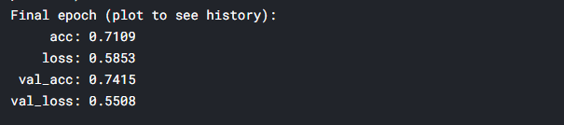

# PLOT THE RESULTING MODEL AS TRAINED

plot(stores_cluster_training_model)

